CS 255 System Design Document

UML Diagrams

UML Use Case Diagram
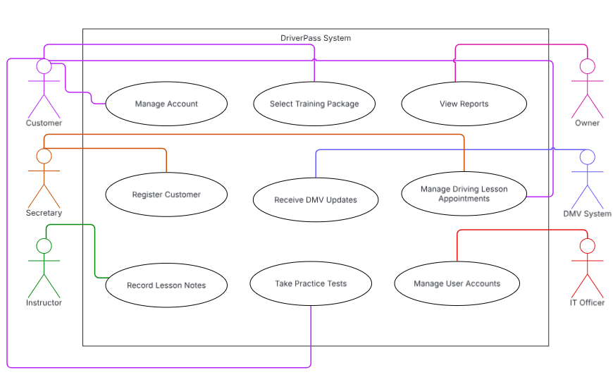

UML Activity Diagrams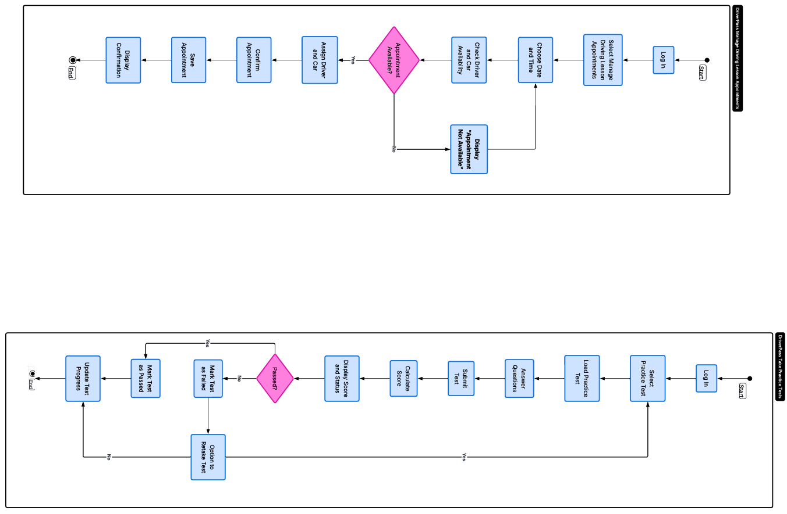

UML Sequence Diagram
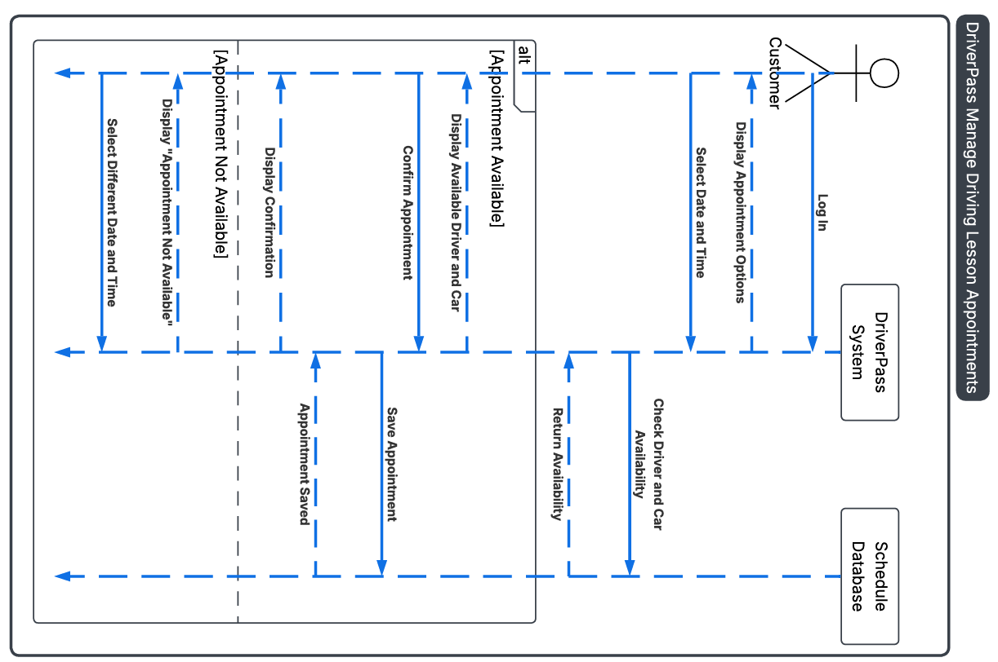

UML Class Diagram
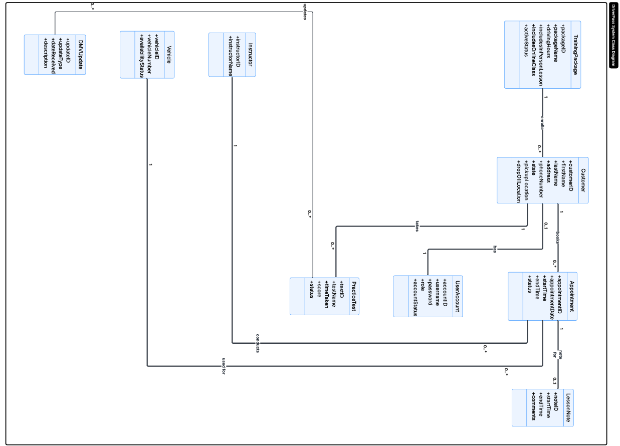

Technical Requirements
Hardware
- DriverPass employees will need computers or mobile devices with a reliable internet connection to access the system.
- Customers should be able to use the system from a computer, tablet, or phone without needing any special equipment.
- The system should be able to support DriverPass’s current 10 cars and drivers when checking availability and scheduling driving lessons.
Software
- The system should be web-based and work on current versions of common browsers such as Chrome, Edge, Safari, and Firefox.
- The interface should work on both computer and mobile screen sizes.
- A secure database will be needed to store the information shown in the system design, including customer accounts, training packages, appointments, instructors, vehicles, lesson notes, practice test results, and DMV updates.
- Common pages such as login, scheduling, customer records, and practice tests should load within three seconds under normal conditions.
- When a customer selects a date and time for a driving lesson, the system should check the instructor and vehicle schedule before allowing the appointment to be saved.
- The system should prevent a customer, instructor, or vehicle from being scheduled for more than one lesson at the same date and time.
- Each driving lesson should be recorded as two hours, so the number of scheduled sessions matches the customer’s training package.
- Practice tests should store the test name, time taken, score, and status so the customer’s progress can be updated after a test is completed.
- Reports should be available in an Excel-compatible format so authorized employees can download and review them offline.
- Records should only be changed while the user is connected to the online system to help prevent duplicating or conflicting information.
Tools
- Lucidchart can be used to create and update the UML diagrams used for the system design.
- The system will need a way to create customers, reservations, progress, and activity reports.
- It will also need a way to receive DMV notifications when rules, policies, or sample questions change so authorized employees can update course materials and practice tests.
- Forms should include clear labels, required fields, confirmation messages, and error messages so users know if information was entered or saved correctly.
Infrastructure
- DriverPass should use cloud hosting, so the company does not have to maintain its own servers.
- The cloud service should handle backups, system recovery, and basic security. Backups should be completed at least once each day so recent information can be restored if there is a system problem.
- Access should be based on the user’s role. Customers, instructors, the secretary, owner, and IT officer should only have access to the information and functions they need.
- The IT officer should be able to create, update, reset, disable, or block user accounts when needed.
- Accounts should temporarily lock after three failed login attempts and unlock after 15 minutes or with help from the IT officer.
- Passwords should be at least eight characters and include letters, numbers, and a special character.
- The system should keep a history of who created, changed, or canceled an appointment and who made the most recent update.
- DriverPass should be alerted when there is a repeated login failure, scheduling conflict, failed DMV update, or information that cannot be saved correctly.
- Authorized employees should be able to disable an existing training package without changing the system code. Adding or removing package modules would still require future development.
- The system should normally be available to customers and employees except during planned maintenance or an unexpected cloud service outage.

